**NAME: SRADHA KEDIA**

**COURSE: MCA**

**ROLL NO.: 57**

**ASSIGNMENT 1**

**Ques 1**: What are the types of communication? Explain semantic barriers in communication in detail.

**Answer 1 -**

**Definition:**

The **Communication** is a two-way process wherein the information, ideas, opinions, thoughts, feelings, etc. are transmitted between the individuals through the use of mutually understood symbols and semiotic rules (signs and symbols).

Types of Communication:

**1) Interspecific Communication -** Much animal communication is intraspecific, that is, it occurs between members of the same species. As for interspecific communication, that between predator and prey is of particular interest.

* Prey to predator
* Predator to prey
* Human/animal communication

**2) Intraspecific Communication** – Within same species

* Honey bee Dance

Further, there are several forms of communication that the individuals use to give some pattern or expression to their messages such that it is easily understood by all. The most common types of communication are:

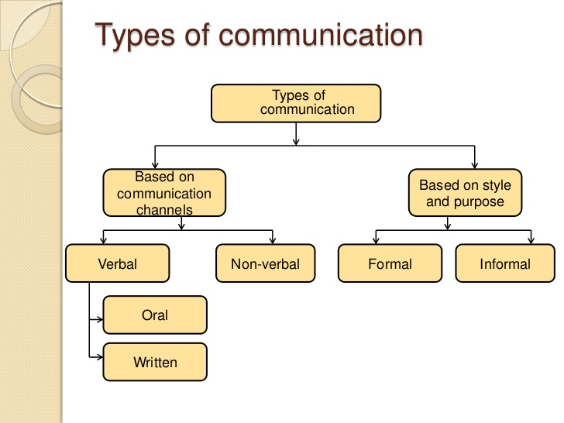

**1)Verbal Communication -**The Verbal Communication is a type of oral communication wherein the message is transmitted through the spoken words. Here the sender gives words to his feelings, thoughts, ideas and opinions and expresses them in the form of speeches, discussions, presentations, and conversations.

The effectiveness of the verbal communication depends on the tone of the speaker, clarity of speech, volume, speed, body language and the quality of words used in the conversation. In the case of the verbal communication, the feedback is immediate since there are a simultaneous transmission and receipt of the message by the sender and receiver respectively. The success of the verbal communication depends not only on the speaking ability of an individual but also on the listening skills. How effectively an individual listens to the subject matter decides the effectiveness of the communication. The verbal communication is applicable in both the formal and informal kind of situations.

**2)Non-Verbal Communication –**The Non-Verbal Communication types include facial expressions, gestures, paralinguistics such as loudness or tone of voice, body language, proxemics or personal space, eye gaze, haptics (touch), appearance, and artifacts.

Nonverbal communication delivers a message without the use of words. Nonverbal cues through body language, facial expressions, and tone of voice are given and interpreted in this form of communication. A shrug of the shoulders could indicate indifference while waving of hands could be enough to say goodbye and a simple nod may show acceptance.

While nonverbal communication and behaviour can vary dramatically between cultures, the facial expressions for happiness, sadness, anger, and fear are similar throughout the world.



**3) Formal Communication:** Formal communication refers to the flow of official information through proper, predefined channels and routes. The flow of information is controlled and needs deliberate effort to be properly communicated. Formal communication follows a hierarchical structure and chain of command. The structure is typically top down, from leaders in various departments and senior staff in the organization, which funnel down to lower-level employees. Employees are bound to follow formal communication channels while performing their duties. Formal communication is considered effective as it is a timely and systematic flow of communication.

**4) Informal Communication:** Informal Communication refers to communication which is multi-dimensional. Informal communication moves freely within the organization and is not bound by pre-defined channels and communication routes. Informal communication is particularly quick. Informal communication is far more relational than formal communication and is by nature, a very natural form of communication as people interacts with each other freely and can talk about a diverse range of topics, often extending outside of their work duties. Due to the inherent nature of informal communication, it moves a lot faster and does not have a paper trail.

Semantic Barriers: The use of difficult and multiple use of languages, words, figures, symbols create semantic barriers.

* **Language**– A meaning sent by the sender can be quite different from the meaning understood by the receiver. Long and complex sentences create problem in communication process.
* **Jargon**– Technical or unfamiliar language creates barriers. The message should be simple and condensed as far as possible so that no confusion is created.

**Ques 2:** Write short note on the following:

**Answer 2-**

**a) Diagonal Communication** is the communication held between different structures of a business firm. It is the communication between the higher and lower sectors of a business firm. It is also known as cross-functional communication.

Advantage: -

The shortest distance between two points is a straight line. Diagonal communication routes are the straight lines that speed communications directly to their recipients, at the moment communication is necessary.

And as a result, it ends communication barriers between the higher and lower sectors of a business.

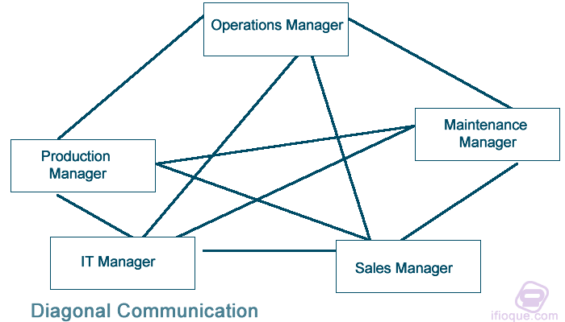

**b) Grapevine communication** is a communication held without following a recommended structure in an organization is informal communication. So, grapevine communication can be described as a casual and unofficial communication system within the organization.

E.g., Think of the lunch meetings you attend with your team. The conversation during such times revolves around your work, yet it remains unofficial and forms informal or personal relationships between you and your team members.

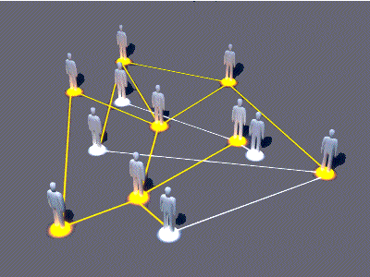

**c) Paralanguage** refers to the non-verbal elements of communication used to modify meaning and convey emotion. Paralanguage may be expressed consciously or unconsciously, and it includes the pitch, volume, and, in some cases, intonation of speech. Sometimes the definition is restricted to vocally-produced sounds.

The study of paralanguage is known as paralinguistics. An example of paralanguage is the pitch of your voice.

**Ques 3**: Describe body language in detail.

**Answer 3 –**

Body language is the range of nonverbal signals that you use to communicate your feelings and intentions. These include your posture, facial expressions, and hand gestures. Your ability to understand and interpret body language can help you to pick up on unspoken issues or negative feelings in others.

You can also use body language in a positive way to add strength to your verbal messages. The many different types of nonverbal communication or body language include

**Facial expressions**. The human face is extremely expressive, able to convey countless emotions without saying a word. The facial expressions for happiness, sadness, anger, surprise, fear, and disgust are the same across cultures.

**Body movement and posture**. Consider how your perceptions of people are affected by the way they sit, walk, stand, or hold their head.

**Gestures**. Gestures are woven into the fabric of our daily lives. You may wave, point, beckon, or use your hands when arguing or speaking animatedly, often expressing yourself with gestures without thinking.

**Eye contact**. Since the visual sense is dominant for most people, eye contact is an especially important type of nonverbal communication. The way you look at someone can communicate many things, including interest, affection, hostility, or attraction

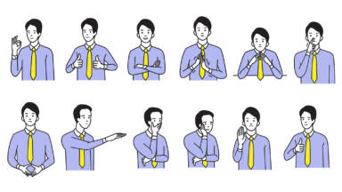

**Ques 4:** What are the five distinctive features of writing?

**Answer 4 –**

The five Features of Effective Writing are focus, organization, support and elaboration, grammatical conventions, and style.

**1)Thesis Focus:**

Focus is the topic/subject/thesis established by the writer in response to the writing task. The writer must clearly establish a focus as he/she fulfils the assignment of the prompt. If the writer retreats from the subject matter presented in the prompt or addresses it too broadly, the focus is weakened. Writers may effectively use an inductive organizational plan which does not actually identify the subject matter at the beginning and may not literally identify the subject matter at all. The presence, therefore, of a focus must be determined in light of the method of development chosen by the writer. If the reader is confused about the subject matter, the writer has not effectively established a focus. If the reader is engaged and not confused, the writer probably has been effective in establishing a focus.

**2)Organization:**

Organization is the progression, relatedness, and completeness of ideas. The writer establishes for the reader a well-organized composition, which exhibits a constancy of purpose through the development of elements forming an effective beginning, middle, and end. The response demonstrates a clear progression of related ideas and/or events and is unified and complete.

**3)Support and Elaboration:**

Support and Elaboration form the extension and development of the topic/subject/thesis. The writer provides sufficient elaboration to present the ideas and/or events clearly. Two important concepts in determining whether details are supportive are the concepts of relatedness and sufficiency. To be supportive of the subject matter, details must be related to the focus of the response. Relatedness has to do with the directness of the relationship that the writer establishes between the information and the subject matter. Supporting details should be relevant and clear. The writer must present his/her ideas with enough power and clarity to cause the support to be sufficient. Effective use of concrete, specific details strengthen the power of the response. Insufficiency is often characterized by undeveloped details, redundancy, and the repetitious paraphrasing of the same point. Sufficiency has less to do with amount than with the weight or power of the information that is provided.

**4)Grammatical Conventions:**

Grammatical conventions involve correctness in sentence formation, usage, and mechanics. The writer has control of grammatical conventions that are appropriate to the writing task. Errors, if present, do not impede the reader’s understanding of the ideas conveyed.

**5)Style:**

Style is the control of language that is appropriate to the purpose, audience, and context of the writing task. The writer’s style is evident through word choice and sentence fluency. Skilful use of precise, purposeful vocabulary enhances the effectiveness of the composition through the use of appropriate words, phrases and descriptions that engage the audience. Sentence fluency involves using a variety of sentence styles to establish effective relationships between and among ideas, causes, and/or statements appropriate to the task.

**Ques 5**: Explain non-verbal communication. Elaborate the different types of listening

**Answer 5 –**

Nonverbal communication is the transfer of information through the use of body language including eye contact, facial expressions, gestures and more. For example, smiling when you meet someone conveys friendliness, acceptance and openness. Everyone uses nonverbal communication all the time whether they know it or not. There are several ways nonverbal communication can support your ability to communicate effectively in the workplace, including:

**Supports your message**. When having a conversation, participating in a meeting or engaging in conversation, nonverbal cues can emphasize and underscore the content of your message. For example, using hand gestures to indicate the importance of an idea may tell your listeners to pay attention to and remember a key point.

**Communicates messages**. You may also use nonverbal communication completely to communicate with others. For example, if someone is explaining a sentiment you admire and agree with, you might nod your head up and down to express solidarity.

**Communicates intention**. Your body language may also intentionally or unintentionally express your current condition. For example, people may pick up nonverbal cues that you are being dishonest, unengaged, excited or aggressive.

**Conveys feelings**. You can also use nonverbal communication to show your feelings, such as disappointment, relief, happiness, contentment and more.

**Offers support**. Nonverbal cues are also a great way to show support. Whether it's a simple smile or pat on the back, action may speak louder than words in many cases.

**Showcases your personality**. Nonverbal communication is a great way to show who you are. For example, a kind and optimistic person might frequently smile with open body language and offer friendly touches.

Body language, movement, gesture, eye contact, space, facial expressions, paralanguage etc are example of non-verbal communication.

**Types of listening: -**

Most people, most of the time, take listening for granted, it’s something that just happens.  It is only when you stop to think about listening and what it entails that you begin to realise that listening is in fact an important skill that needs to be nurtured and developed. The two main types of listening - the foundations of all listening sub-types are:

**Discriminative Listening**

**Comprehensive Listening**

1)Discriminative listening is first developed at a very early age – perhaps even before birth, in the womb.  This is the most basic form of listening and does not involve the understanding of the meaning of words or phrases but merely the different sounds that are produced.  In early childhood, for example, a distinction is made between the sounds of the voices of the parents – the voice of the father sounds different to that of the mother.

Example: Imagine yourself surrounded by people who are speaking a language that you cannot understand.   Perhaps passing through an airport in another country.  You can probably distinguish between different voices, male and female, young and old and also gain some understanding about what is going on around you based on the tone of voice, mannerisms and body language of the other people.  You are not understanding what is being said but using discriminative listening to gain some level of comprehension of your surroundings.

2)Comprehensive listening involves understanding the message or messages that are being communicated.  Like discriminative listening, comprehensive listening is fundamental to all listening sub-types. Comprehensive listening is complimented by sub-messages from non-verbal communication, such as the tone of voice, gestures and other body language. The three main types of listening most common in interpersonal communication are:

Informational Listening (Listening to Learn)

Critical Listening (Listening to Evaluate and Analyse)

Therapeutic or Empathetic Listening (Listening to Understand Feeling and Emotion)